DevOps Day 2
1. Introduction to SCM Tool (Source Code Management)
- SCM stands for Source Code Management.
- It helps developers track, manage, and control code changes during software development.
- It allows multiple people to work together on the same project safely.
- SCM keeps a version history, so you can easily go back to older code.
Examples: Git, SVN (Subversion), Mercurial, Perforce.
Key Benefits:
- Tracks every code change.
- Helps teamwork and collaboration.
- Prevents code loss or overwriting.
- Allows rollback to earlier versions.

2. Difference Between Centralized and Distributed VCS
Aspect | Centralized VCS (CVCS) | Distributed VCS (DVCS)
Repository | One central server stores all code. | Every developer has a full local copy of the repository.
Internet Requirement | Needs internet to commit or update code. | Can work offline and sync later.
Speed | Slower – depends on network and central server. | Faster – most work happens locally.
Data Safety | If server crashes, data may be lost. | Every user has a backup copy.
Examples | SVN, CVS | Git, Mercurial
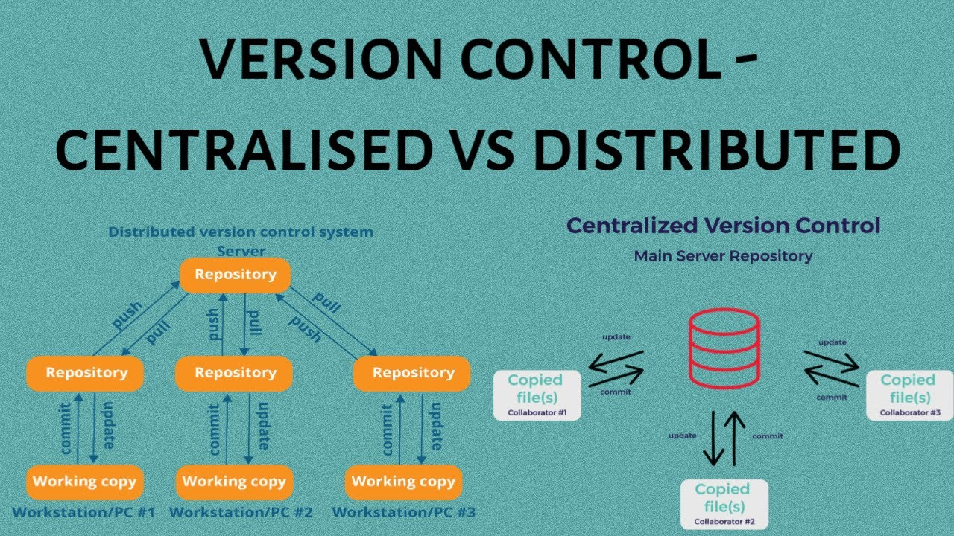

3. Introduction to Git
- Git is a Distributed Version Control System (DVCS) created by Linus Torvalds in 2005.
- It helps teams manage source code, track changes, and work in parallel.
Key Features:
- Works offline (local commits).
- Fast and reliable.
- Supports branching and merging.
- Keeps full project history.
- Used with hosting services like GitHub, GitLab, and Bitbucket.

Workflow Of GIT
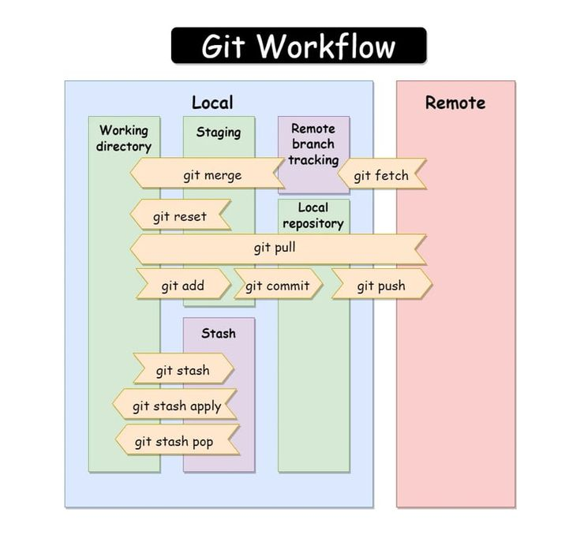
4. Git Branches and Common Operations

Git Branch
- A branch in Git is like a separate line of development.
- It lets you work on a new feature or fix without affecting the main code.
Common Branch Types:
- Main / Master: The main production-ready branch.
- Develop: For ongoing development.
- Feature: For new features or modules.
- Bugfix: For fixing specific issues.
- Release: For preparing final versions before deployment.
Common Commands:
- git branch → Lists all branches.
- git branch <branch-name> → Creates a new branch.
- git checkout <branch-name> → Switches to another branch.
- git merge <branch-name> → Combines another branch into the current branch.
- git diff → Shows the difference between file versions or branches.

5. Introduction to Remote Repository (GitHub)
- A Remote Repository is an online version of your Git project.
- It allows team members to share, sync, and collaborate from different systems.
- GitHub is the most popular remote repository hosting platform.
Common Git Remote Commands:
- git remote add origin <repo-url> → Connect your local repo to a remote one.
- git push origin <branch-name> → Upload local changes to GitHub.
- git pull origin <branch-name> → Download and merge changes from GitHub.
- git clone <repo-url> → Copy a remote repository to your local system.
Benefits of Remote Repositories:
- Enables teamwork and collaboration.
- Keeps backups of your code online.
- Integrates with CI/CD tools for automation.

Helps with version tracking and open-source sharing.
GIT Commands (Work on Local Repository)

git init
Create a new empty Git repository in your current folder.
Use:
git init
Example:
If you have a folder named 'myproject', open it in terminal and run 'git init' to start version control.

git add
Add files to the staging area (prepare them for commit).
Use:
git add <filename>
git add . # adds all files in the folder
Example:
git add index.html

git commit
Save changes from the staging area to the local repository with a message.
Use:
git commit -m "Your commit message"
Example:
git commit -m "Added homepage file"

git status
Show the current state of files — which are modified, staged, or untracked.
Use:
git status
Example Output:
modified: index.html
untracked files: style.css

git log
View the history of commits in the repository.
Use:
git log
Example Output:
commit a1b2c3d4
Author: Shivansh
Date: Thu Oct 09 17:00 2025
Message: Added homepage

git restore
Undo changes in files that are not yet staged or committed.
Use:
git restore <filename>
Example:
git restore index.html
(Restores the file to the last committed version)

git revert
Undo a specific commit by creating a new commit that reverses it (keeps history safe).
Use:
git revert <commit_id>
Example:
git revert a1b2c3d4
(This creates a new commit that cancels out the changes of the mentioned commit.)

Summary Table
Command | Description | Example
git init | Start a new Git repository | git init
git add | Stage files for commit | git add .
git commit | Save changes with message | git commit -m "msg"
git status | Check current status | git status
git log | View commit history | git log
git restore | Undo unstaged changes | git restore file.txt
git revert | Undo a specific commit | git revert id

# Exercise 1.1: Create and Initialize a Repository
mkdir my-project
cd my-project
git init

# Exercise 1.2: Verify initialization
ls -la # Linux/Mac
dir /a # Windows
# You should see a .git folder

# Exercise 1.3: Check git status in empty repo
git status
-----------------------------------------------------------------------
# Exercise 2.1: Check initial status
git status

# Exercise 2.2: Create files and check status
echo "Hello Git" > file1.txt
echo "Learning Git" > file2.txt
git status
# Notice: Files appear as "untracked"

# Exercise 2.3: Create multiple files and check
mkdir docs
echo "Documentation" > docs/readme.txt
git status
# Notice: Entire folder appears as untracked
------------------------------------------------------------------------------------

# Exercise 3.1: Add single file
git add file1.txt
git status
# Notice: file1.txt is now "staged" (green), file2.txt still "untracked" (red)

# Exercise 3.2: Add multiple files
git add file2.txt docs/readme.txt
git status
# All files should now be staged

# Exercise 3.3: Modify and stage
echo "Additional line" >> file1.txt
git status
# Notice: file1.txt appears in both staged and modified

# Exercise 3.4: Stage all changes
git add .
git status

# Exercise 4.1: First commit
git commit -m "Initial commit: Added project files"
git status
# Working directory should be clean

# Exercise 4.2: Make changes and commit
echo "New feature" > feature.txt
git add feature.txt
git commit -m "Add feature file"

# Exercise 4.3: Modify and commit with combined command
echo "Update" >> file1.txt
git commit -am "Update file1 content"
# Note: This only works for already tracked files

# Exercise 4.4: Multi-line commit message
git add .
git commit -m "Major update
- Added new documentation
- Updated existing files
- Prepared for next phase"
# Exercise 5.1: Basic log
git log

# Exercise 5.2: Compact log view
git log --oneline

# Exercise 5.3: Limited commits
git log -3 # Last 3 commits
git log --oneline -5 # Last 5 commits in one line

# Exercise 5.4: Detailed log with statistics
git log --stat

# Exercise 5.5: Custom format
git log --pretty=format:"%h - %an, %ar : %s"
# %h = hash, %an = author, %ar = relative time, %s = subject
# Exercise 6.1: Discard working directory changes
echo "Unwanted change" >> file1.txt
git status
git restore file1.txt
git status
cat file1.txt # Change is gone

# Exercise 6.2: Restore multiple files
echo "Bad edit" >> file1.txt
echo "Another bad edit" >> file2.txt
git restore . # Restore all files
git status

# Exercise 6.3: Unstage files
echo "New content" > new-file.txt
git add new-file.txt
git status
git restore --staged new-file.txt
git status # File is unstaged but still exists

# Exercise 6.4: Restore to specific commit
git log --oneline
git restore --source=HEAD~1 file1.txt # Restore from previous commit
# Exercise 7.1: Setup - Create commits to revert
echo "Version 1" > app.txt
git add app.txt
git commit -m "Add app.txt version 1"

echo "Version 2" >> app.txt
git commit -am "Update to version 2"

echo "Version 3 - Bug!" >> app.txt
git commit -am "Update to version 3 with bug"

git log --oneline

# Exercise 7.2: Revert the last commit
git revert HEAD
# Editor opens for commit message, save and exit
git log --oneline # New revert commit appears
cat app.txt # Bug is removed

# Exercise 7.3: Revert a specific commit
git log --oneline
git revert HEAD~1 # Revert second-to-last commit
# Might cause conflicts - resolve if needed

# Exercise 7.4: Revert without auto-commit
echo "Feature A" > feature-a.txt
git add feature-a.txt
git commit -m "Add feature A"
git revert HEAD --no-commit
git status # Changes staged but not committed
git commit -m "Manually revert feature A"

📝 Comprehensive Practice Project

Create a Mini Todo List Project

# Step 1: Initialize project
mkdir todo-app
cd todo-app
git init

# Step 2: Create initial files
echo "# Todo List App" > README.md
echo "Buy groceries" > tasks.txt
git status

# Step 3: Stage and commit
git add .
git commit -m "Initial commit: Setup todo app"

# Step 4: Add more tasks
echo "Complete Git tutorial" >> tasks.txt
echo "Review notes" >> tasks.txt
git status
git diff # See what changed
git add tasks.txt
git commit -m "Add learning tasks"

# Step 5: Create mistake and fix it
echo "This is wrong!" > tasks.txt
git status
git restore tasks.txt # Undo the mistake

# Step 6: Add priority system
echo "HIGH: Fix bugs" > priority-tasks.txt
echo "LOW: Clean desk" >> priority-tasks.txt
git add priority-tasks.txt
git commit -m "Add priority task system"

# Step 7: View history
git log --oneline --graph

# Step 8: Accidentally delete content
echo "" > README.md
git add README.md
git commit -m "Accidentally cleared README"

# Step 9: Revert the mistake
git log --oneline
git revert HEAD
git log --oneline

# Step 10: Final status check
git status
ls
cat README.md # Should be restored

